

**School Based Mentoring Program**

**Vision: 100% Student Success**

**Mission: Educate and prepare each student for college, career and life.**

**PCS Mentoring Programs**

* **Lunch Pals:** A one-to-one mentoring program designed to provide students with the additional presence of a caring, consistent and committed adult in their lives. Lunch Pals only: A company that provides employees to be mentors is partnered with a school. Standards and required procedures include:
* Completion of PCS volunteer application.
* Successful completion of Level I Background Screening.
* Attend a Pinellas County School Mentor Training.
  + Commitment to meet with student once a week for 30 minutes, for a school year. *Continue to mentor until student graduates high school.*
* **Take Stock in Children (TSIC):** One-to-one mentoring program in which students in grades 6 -10 are nominated to receive a TSIC scholarship. If awarded, the student will receive a four year scholarship at graduation by fulfilling a contractual agreement to attend school regularly, maintain a C or above in all classes and remain crime and drug free. Students must be matched to a mentor and meet weekly or bi-weekly for 30+ minutes. Requirements include:
* Completion of PCS volunteer application.
* Successful completion of Level I Background Screening.
* Attending Pinellas County School Mentor Training.
  + Commitment to meet with student once a week or bi-weekly for 30 minutes. 15 Session minimum two in a school year to meet scholarship requirements. Continue to mentor until student graduates high school.
* Mentors receive a TSIC program guide.
* **5000 Role Models of Excellence:** A group mentoring program designed to boost the self-image and, increase social skills and academic performance of targeted males. Groups meet twice a month during the school day. Standards and required procedures include:
  + Completion of PCS volunteer application
  + Successful completion of Level I Background Screening.
  + Attending Pinellas County School Mentor Training.
    - Mentors are provided a program curriculum to follow for this program.
* **Girlfriends of Pinellas County:** A group mentoring program for 4th – 12th grade girls to empower through academic support and mentorship. Students are provided with the resources, tools and guidance necessary to encourage self-discipline, positive behavior, and to cultivate high self-esteem and self-reliance. Standards and required procedures include:
  + Completion of PCS volunteer application.
  + Successful completion of Level I Background Screening.
  + Attending Pinellas County School Mentor Training.
    - Program curriculum provided.
* **Peer-to-Peer:** Key student leaders in the 11th and 12th grade are selected to become Peer to Peer mentors to students transitioning into 9th grade. Peer mentors provide guidance, support and act as a role model throughout the school year. Requirements:
  + Completion of PCS volunteer application.
  + Successful completion of Level I Background Screening.
  + Attending Pinellas County School Mentor Training.
    - Program curriculum provided.
* **Big Brothers Big Sisters:** One-to-one mentoring for elementary and middle-school children designed to improve academic, social and behavioral performance. Standards and required procedures include:
* Orientation: required for all parent/guardians and volunteers to determine appropriateness for participation and provide an overview of services provided.
* Level 2 Volunteer Screening: required of all potential adult volunteers and is designed to screen out those who may inflict psychological or physical harm, those who lack the capacity to form a caring bond with the child, or those who are unlikely to honor their time commitments. Includes a detailed written application including references, a background check, and an extensive interview including personal questions regarding childhood experiences, sexual orientation and present family situation.
* Youth Assessment: required for all youth entering the program, designed to help BBBS staff learn about the youth to determine best possible match. It also allows staff to secure parental permission. The assessment involves a written application, and interviews with the youth and the parent.
* Matches: are formed carefully and are based upon considerations such as the shared interests of the volunteer and youth, geography, the needs of the youth, the volunteer’s skills and abilities, the preferences of the parent, and the capacity of program staff.
* Supervision: occurs via an initial contact with the youth and volunteer within two weeks of the match; monthly contact with the volunteer, parent, and/or youth during the first year; and quarterly contact with all parties during the duration of the match.
* Completion of PCS volunteer application.

**School Contact**

A Family & Community Liaison is the point of contact for all volunteer/mentors at the school(s) level. All mentors are required to sign in at the front desk, wear a visitor or volunteer badge while on campus, and log their volunteer/mentor hours in the volunteer system.

**Volunteer/Mentor Logging Hours**

Pinellas County Schools’ Volunteer System allows users to record the date, school, length of time, program description, student name and school, and topics covered: Today we…Did an activity or Had a discussion or Both, Topic: Academics/ Education, Career, Personal/Social, It was Positive: Yes, No or N/A, Comments: Mentors are able to type any comment in the field.

**Reporting**

Mentor/Mentee Data tracking: Grades, behavior, attendance, number of mentor visits, program mentee is in, length of time spent, qualitative data is also used to determine the positive nature of the relationship. Reports are printed mid-and-end of year.

**Pinellas School Board Policy 9180 Volunteers and 2430.03 - MENTORING PROGRAM**

The School Board believes that a mentoring program, whereby a caring adult provides guidance for an individual student, is an effective strategy to help students perform better in school. Therefore, principals or their designee are authorized to contact local businesses and governmental agencies to recruit mentors. Furthermore, employees of the District are encouraged to volunteer as a mentor.

Individuals who volunteer to serve as a mentor will receive training in that role which is approved or conducted by the Office of Strategic Partnerships. All community mentors are subject to a background check by the District.

Any staff member who volunteers to serve as a mentor may be released from his/her duties for up to one (1) hour per week to mentor a student to whom s/he has been assigned. Released time for mentoring shall be approved by the employee's supervisor and shall be scheduled at a time that does not prevent the employee from performing the essential functions of his/her assignment.

**Policy/Guidelines**

* All mentors must be a registered volunteer.
* Level 1 approval.
* Mentors must attend a mentor training.
* A commitment of at least a school year one-hour per week.
* Mentoring activities are limited to school grounds or school sponsored activities.
* No emails, texting, sharing of phone numbers, social media…
* Mentors will meet with students at lunch, or during a non-core subject.

Students are identified and selected to have a mentor by the principal, AP, guidance counselor, teacher, or request from social services, parent(s) or guardian.Students can also advocate for themselves to have a mentor.

**Student are selected for the following reasons:**

* TSIC Scholarship.
* Poor grades, attendance, behavior.
* Social Issues.
* Self-Esteem.
* Needing an additional caring adult.

**Pinellas County School Eligibility Policy –** All background screening approvals and appeals are based on the following criteria:

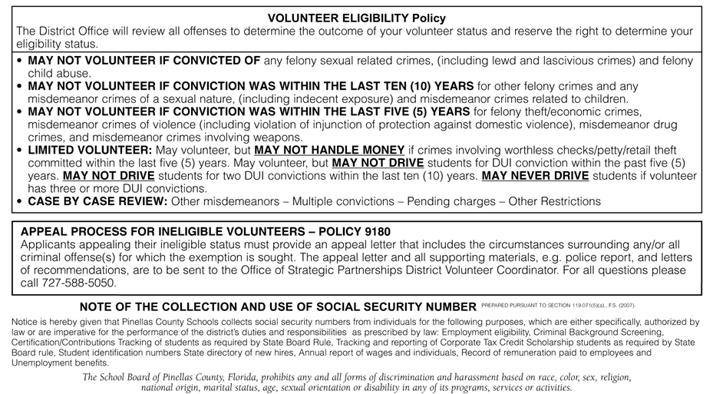

**2015/2016 Mentor Numbers - Total 2894**

310 Lunch Pals

1103 General Mentors

59 Role Models

210 Big Brothers Big Sisters

1072 Take Stock in Children

59 Girlfriends

78 Peer to Peer

3 Other

**Big Brothers Big Sisters School Based Mentoring**

***210 student/mentor pairs***

***Schools with partnerships:*** *8*

Belleair ES

Campbell Park ES

Eisenhower ES

High Point ES

John Hopkins MS

Lakewood ES

Sandy Lane ES

Skyview ES

Thurgood Marshall MS

Tyrone MS

***Additional assorted schools that students have moved to where mentor has continued:*** *25 PCS; 8 private*

**Lunch Pals Participation:**

***Total students being mentored:*** *310*

***Total volunteers trained who are currently mentoring or in process of being matched with a student:*** *417*

***Schools*** *(Present and beginning in Fall)* ***– 26 total***

Azalea MS

Bardmoor ES

Bear Creek ES

Belleair ES

Blanton ES

Campbell Park ES

Dunedin ES

Fairmount Park ES

Gulfport Montessori ES

High Point ES

John Hopkins MS

Lakewood ES

Lealman ES

Lynch ES

Maximo ES/Eckerd College

Melrose ES

Mildred Helms ES

Mt. Vernon ES

North Shore ES

Oldsmar ES

Pinellas Park ES

Ponce de Leon

Sandy Lane ES

Seminole Schools

Seventy Fourth Street ES

Skyview ES

***Partners*** *(Present and beginning in Fall)* ***– 33 total***

Ajax Building

Bayfront Health St. Petersburg

Calvary Chapel

Ceridian

City of Clearwater

City of Dunedin

City of Largo

City of Pinellas Park

City of Seminole

City of St. Petersburg

Coast Guard

Cox Media

Eckerd College

FIS Global

Fred G Minnis

Friends of North Shore

Juvenile Welfare Board

Pinellas County Government

Pinellas County Schools

Pinellas Sheriff’s Police Athletic League, Inc.

Power Design

Raymond James

St Petersburg College - Clearwater

St Petersburg College - Downtown

St Petersburg College – Gibbs

St. Petersburg Police

Sembler

Southside St. Petersburg Community PTA

Stetson University College of Law

Tech Data

University of South Florida St. Petersburg

Westminster Suncoast

West Pharmaceutical

**2015-16 Priority Schools** (25 DA:Differentiated Accountability) – Lunch Pals Schools in bold.

**Azalea MS**

**Bear Creek ES**

**Belleair ES**

**Blanton ES**

**Campbell Park ES**

**Dunedin ES**

**Fairmount Park ES**

**Gulfport Montessori ES**

**High Point ES**

**John Hopkins MS**

**Lakewood ES**

Largo MS

**Lealman ES**

**Lynch ES**

**Maximo ES**

Meadowlawn MS

**Melrose ES**

New Heights ES

**North Shore ES**

**Pinellas Park ES**

Pinellas Park MS

**Ponce de Leon ES**

**Sandy Lane ES**

**2 - Seventy Fourth ES**

10 -Tarpon Springs ES

**Mentor – The National Mentoring Partnership**

***Elements of Effective Practice for Mentoring*** *(Standards/Best Practices)*

<http://www.mentoring.org/program-resources/national-mentoring-resource-center/>